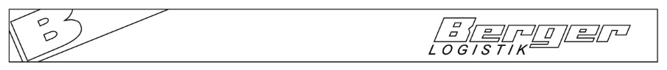
Berger Logistik GmbH, Bahnhofplatz 1, A-6300 Wörgl
Firma

Ihr Zeichen | Unser Sachbearbeiter | Durchwahl | Datum

Dear XXX,

due to fact that Airlines like Lufthansa, Swiss Airline and Turkish Airlines are starting to give penaltys to use printed documents we are starting to implement the eAWB Form as Lufthansa and Swiss Airlines are suggesting.

As eAWB we would send you the whole complete pre alert as before, but you will only receive at Destination Airport the MAWB Scan of this cargo.
In addition we can send you an eAWB with Pouch, in this Pouch there are documents like invoice, packing list and HAWB scans. Original documents from shipper are rare as they only use scans.

So there are 2 different eAWB

EAW = this is the AWB without any documents, you will receive the MAWB at Destination Airport only
EAP = this is the AWB with an Pouch where scans of documents like Invoice, packing List and HAWB are inserted.

Are you familiar with this, or do you still need original documents for shipments into CHINA ?

With best regards

Berger Logistik GmbH

